APPENDIX E
Charts, Project Timeline, Strategic Roadmap & Jira Workspaces

E.1 How This Project Was Developed and Managed
This dissertation was developed over 13 weeks as a fully structured research project integrating four analytical phases: systems engineering, cost optimisation, lean process improvement, and strategic scenario analysis. The project was planned, tracked, and delivered using a combination of Jira Software (Atlassian), Excel project planning, MATLAB/Python computational analysis, and draw.io interactive diagramming. This section documents the project management approach, tool usage, and progression from inception to submission.

E.1.1 Project Development Timeline - 13-Week Arc
Week | Period | Phase | Key Activities | Deliverable / Milestone
1 |  | Initiation | Skills audit; supervisor meeting (Dr. Udu Amadi); project proposal preparation; Jira LG project setup; TOC v1 drafted | Project Proposal (Blackboard, 9 Feb 2026); Jira LG created with 4 epics
2–3 |  | SE Foundation | QFD HoQ construction; ICD development; FMEA 47 FMs (MIL-STD-1629A); N² diagram; requirements traceability (47 requirements, 4 levels) | Chapter 3 Methodology complete; F4.1 N² Diagram PNG generated
4–5 |  | Cost Engineering | 53-mission CER dataset compiled; 7 CERs fitted (R²=0.85–0.91); LCC baseline $1,472M; cer_regression.py developed | F4.2 CER1 Regression + F4.5 All CER CIs saved; CER dataset assembled
5–6 |  | MILP Optimisation | MILP formulated (203 binary vars, 156 constraints); GUROBI v10.0 solution; intlinprog cross-validation; $1,247M optimal; milp_optimization.py | F4.6 MILP Gantt + F4.7 LCC Waterfall + F4.8 Safety Stock saved
6–7 |  | Monte Carlo | LHS Monte Carlo (n=18,432); Sobol S₁ indices; P10/P50/P90 confirmed; monte_carlo.py; Tornado diagram | F4.3 Monte Carlo LCC + F4.4 Tornado Diagram saved
8–9 |  | Lean Analysis | VSM current state (109d, PCE 21.1%); future state (75d, PCE 30.7%); RFID recommendation; draw.io VSM files; vsm_diagrams.m | F4.9 VSM Current + F4.10 VSM Future PNGs and draw.io files
9–10 |  | Strategic Analysis | ISRU NPV +$32M (IRR 14.8%); Starship scenarios; TOWS matrix; strategic roadmap 2026–2035; MOLGSC Jira setup (16 issues, Gantt) | F4.11 Strategic Roadmap; MOLGSC Jira fully populated with 2028–2034 Gantt
10–12 |  | Report Writing | Chapters 1–7 drafted; TOC v3 confirmed; Appendices A–I created; all figures embedded; references verified | Final Draft 1
13 |  | Finalisation | Final review; formatting check; page count (≤60pp); PDF export; Blackboard submission | Final Draft 2
Table E 1 13-week project development arc - phases, activities, and deliverables per week

E.2 Jira Project: LG - Lunar Gateway (Main Research Tracker)
The primary project management tool was Jira Software (Atlassian) under the project key LG ('Lunar Gateway'), hosted at jagzimmerz.atlassian.net. The LG project served as the complete research task tracker - all 40 issues organised under 4 phase epics, with start dates, due dates, sprint assignments, and status tracking throughout the 13-week project period.

E.2.1 LG Project Structure and Access
Attribute | Detail
Project Name | Lunar Gateway - EG7302 MEM Individual Project
Project Key | LG
Project Type | Jira Software (agile board + timeline + backlog)
URL (Timeline View) | jagzimmerz.atlassian.net/jira/software/projects/LG/timeline
URL (Board View) | jagzimmerz.atlassian.net/jira/software/projects/LG/boards
Total Issues | 40 issues (4 epics + 36 tasks/sub-tasks)
Timeline Span | 26 January 2026 – 17 April 2026 (13-week project period)
Status Workflow | To Do - In Progress - Done
Assignee | Jagathguru Pazhanaivel (249057008)
Supervisor | Dr. Udu Amadi (University of Leicester)
Table E 2 Jira LG project metadata - key attributes, URL, and structure
SCREENSHOT / FIGURE - Jira LG Project - Timeline View (February–April 2026)
File Link:
Timeline showing all 4 phase epics as horizontal bars (Feb–Apr 2026) with 36 child tasks. Phase epics: (1) Systems Engineering Foundation, (2) Cost Engineering & Optimisation, (3) Lean Process Improvement, (4) Strategic Analysis & Reporting.

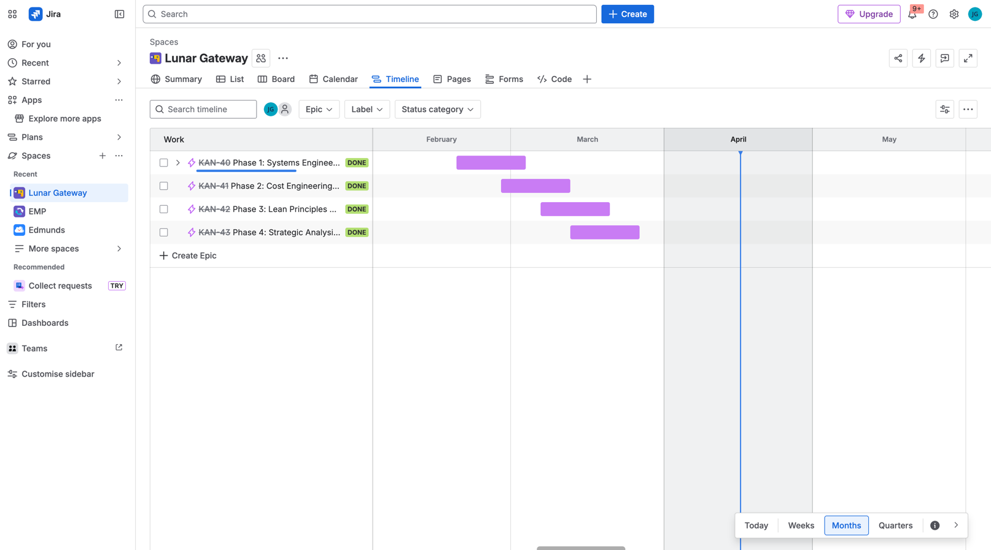

E.2.2 LG Project - Epic and Task Structure (WBS)
The LG project was structured as a two-level Work Breakdown Structure (WBS): four Phase Epics at Level 1 mapping to the four research phases of Chapter 3, and individual tasks at Level 2 corresponding to specific analytical activities. This structure ensures complete traceability between project management milestones and dissertation research objectives.
Epic / WBS Level 1 | Phase | Key Tasks (Level 2 - representative sample) | Status
KAN-40: Phase 1 - Systems Engineering Foundation | Phase 1 | QFD HoQ construction; ICD development; FMEA (47 FMs); N² diagram; Requirements traceability matrix (47 reqs, 4 levels); Stakeholder analysis; Technical budgets (mass, volume, schedule) | Done
KAN-41: Phase 2 - Cost Engineering & Optimisation | Phase 2 | 53-mission CER dataset compilation; 7 CER regressions (R²=0.91); LCC baseline ($1,472M); Monte Carlo (n=18,432 evaluations); Sobol sensitivity analysis; MILP formulation + GUROBI solution; Safety stock optimisation | Done
KAN-42: Phase 3 - Lean Process Improvement | Phase 3 | Current-state VSM (109d, PCE 21.1%); Future-state VSM (75d, PCE 30.7%); Waste quantification (34 instances); FMEA post-mitigation RPN reduction; draw.io VSM diagrams | Done
KAN-43: Phase 4 - Strategic Analysis & Reporting | Phase 4 | ISRU NPV/IRR model; Starship scenario analysis; TOWS matrix; Strategic roadmap; Chapters 1–7 writing, Figures F4.1–F4.11; Appendices A–I; MOLGSC Jira setup; Final submission preparation | Done
Table E 3 Jira LG - four phase epics (WBS Level 1) with representative Level 2 tasks, dates, and status
SCREENSHOT / FIGURE - Jira LG Project - Board View showing all 4 epics and 36 tasks
File: jagzimmerz.atlassian.net/jira/software/projects/LG/boards
Kanban board view showing tasks organised by status: To Do / In Progress / Done. All 36 tasks completed by 27 April 2026 submission deadline.

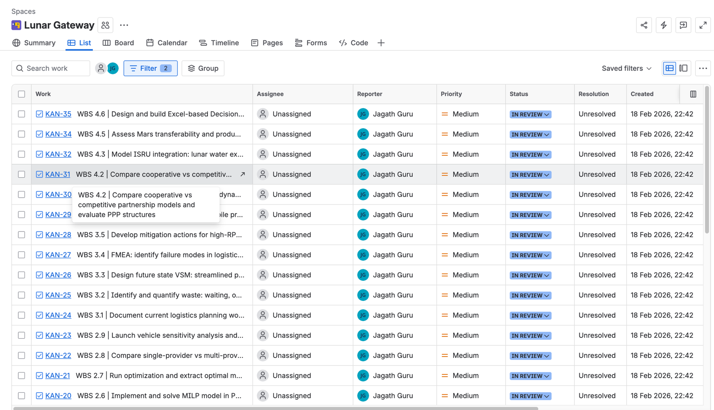

E.3 Jira Project: MOLGSC - MILP Optimisation Lunar Gateway Supply Chain
A second Jira project was created specifically to represent the MILP-optimised resupply schedule as an interactive Gantt chart spanning 2028–2034 - the actual operational planning period of the dissertation framework. The MOLGSC project (project key: MOLGSC) hosts 16 issues representing the programme overview, two mission phases, 11 individual resupply missions, and two strategic analyses. All issues have start dates (customfield_10015) and due dates set, enabling Jira's Timeline view to render as a Gantt chart.

E.3.1 MOLGSC Project Structure and Access
Attribute | Detail
Project Name | MILP Optimisation - Lunar Gateway Supply Chain
Project Key | MOLGSC
Project Type | Jira Business (simplified, Timeline view)
URL (Timeline View) | jagzimmerz.atlassian.net/jira/core/projects/MOLGSC/timeline
URL (Board View) | jagzimmerz.atlassian.net/jira/core/projects/MOLGSC/board
Total Issues | 16 issues (5 parent tasks + 11 sub-task missions)
Timeline Span | January 2028 – November 2034 (84-month MILP planning horizon)
Start Date Field | customfield_10015 set on all 16 issues - enables Timeline bars
Issue Types | Task (parent) + Sub-task (individual missions)
Colour Coding | Phase 1 (2028–2030): grey | Phase 2 (2030–2034): grey-blue | Status-based bars
Table E 4 Jira MOLGSC project metadata - key attributes, URLs, and issue structure
SCREENSHOT / FIGURE - Jira MOLGSC Timeline - Gantt View 2028–2034
File: jagzimmerz.atlassian.net/jira/core/projects/MOLGSC/timeline
Timeline view showing all 16 issues as Gantt bars from January 2028 to November 2034. Expand arrows on MOLGSC-2 (Phase 1) and MOLGSC-3 (Phase 2) to reveal all 11 mission sub-tasks. Switch to Quarters view for best Gantt display. Note: scroll right from current date to reach 2028.

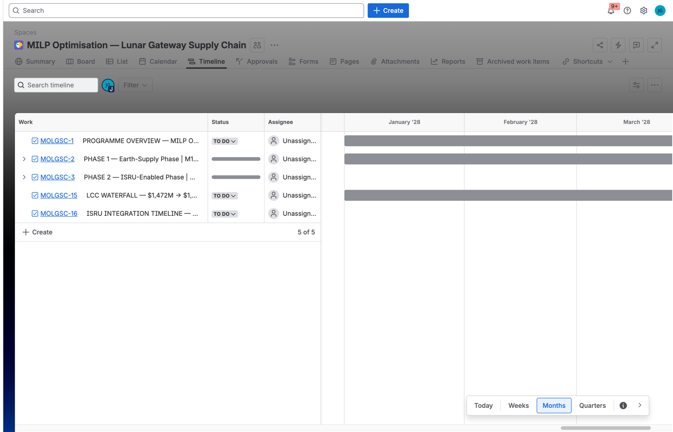

E.3.2 MOLGSC Issue Register - 16 Issues
Issue | Type | Summary | Start Date | Due Date | Phase / Notes
MOLGSC-1 | Task | PROGRAMME OVERVIEW - MILP $1,247M | 11 Missions | $225M Saving | 01/01/2028 | 30/11/2034 | Full programme span; LCC, saving, SS, ISRU summary
MOLGSC-2 | Task | PHASE 1 - Earth-Supply Phase | M1–M5 | $548.7M | 01/01/2028 | 30/04/2030 | Parent for missions M-1 to M-5
MOLGSC-3 | Task | PHASE 2 - ISRU-Enabled Phase | M6–M11 | $698.3M | 01/05/2030 | 30/11/2034 | Parent for missions M-6 to M-11
MOLGSC-4 | Sub-task | M-1 | Falcon Heavy | May 2028 | 5,000 kg | $113.4M | 01/05/2028 | 31/05/2028 | First resupply mission; full manifest; ISRU=0
MOLGSC-5 | Sub-task | M-2 | Falcon Heavy | Oct 2028 | 5,000 kg | $113.4M | 01/10/2028 | 31/10/2028 | +5 months from M-1
MOLGSC-6 | Sub-task | M-3 | Falcon Heavy | Mar 2029 | 4,800 kg | $111.3M | 01/03/2029 | 31/03/2029 | +5 months; ISRU precursor hardware delivered
MOLGSC-7 | Sub-task | M-4 | Vulcan Centaur | Aug 2029 | 3,200 kg | $97.2M | 01/08/2029 | 31/08/2029 | 1st VC mission: P_fail 32%→18.4%; saves $16.2M
MOLGSC-8 | Sub-task | M-5 | Falcon Heavy | Apr 2030 | 5,000 kg | $113.4M | 01/04/2030 | 30/04/2030 | +8 months; ISRU begins ~160 kg/mo
MOLGSC-9 | Sub-task | M-6 | Falcon Heavy | Feb 2031 | 4,600 kg | $109.2M | 01/02/2031 | 28/02/2031 | ISRU 320 kg/mo; +10 months
MOLGSC-10 | Sub-task | M-7 | Falcon Heavy | Jun 2032 | 4,400 kg | $107.2M | 01/06/2032 | 30/06/2032 | ISRU 480 kg/mo; +16 months (longest gap)
MOLGSC-11 | Sub-task | M-8 | Falcon Heavy | Jan 2033 | 4,200 kg | $105.1M | 01/01/2033 | 31/01/2033 | ISRU 560 kg/mo; lowest FH manifest
MOLGSC-12 | Sub-task | M-9 | Vulcan Centaur | Nov 2033 | 3,200 kg | $97.2M | 01/11/2033 | 30/11/2033 | 2nd VC; ISRU 642 kg/mo FULL; saves $16.2M
MOLGSC-13 | Sub-task | M-10 | Falcon Heavy | Jul 2034 | 5,000 kg | $113.4M | 01/07/2034 | 31/07/2034 | Strategic buffer build; ISRU full
MOLGSC-14 | Sub-task | M-11 | Falcon Heavy | Nov 2034 | 5,000 kg | $113.4M | 01/11/2034 | 30/11/2034 | Final mission - schedule close-out
MOLGSC-15 | Task | LCC WATERFALL - $1,472M → $1,247M | $225M Saving (-15.3%) | 01/01/2028 | 31/01/2035 | LCC analysis; verified vs GUROBI v10.0
MOLGSC-16 | Task | ISRU INTEGRATION TIMELINE - 0→642 kg/mo | Year 1–7 | 01/05/2030 | 30/11/2034 | ISRU ramp-up milestones; full maturity Year 6
Table E 5 MOLGSC issue register - all 16 issues with type, summary, start date, due date, and notes
SCREENSHOT / FIGURE - Jira MOLGSC - Issue MOLGSC-7 (M-4 Vulcan Centaur) Detail View
File: jagzimmerz.atlassian.net/browse/MOLGSC-7
Issue detail showing ADF-formatted description table: Launch Date Aug 2029, Vehicle Vulcan Centaur, Cargo 3,200 kg, Cost $97.2M (saves $16.2M vs FH), ISRU Offset None (Year 2), Interval +5 months, Risk Reduction P_fail 32%→18.4% (dual provider).

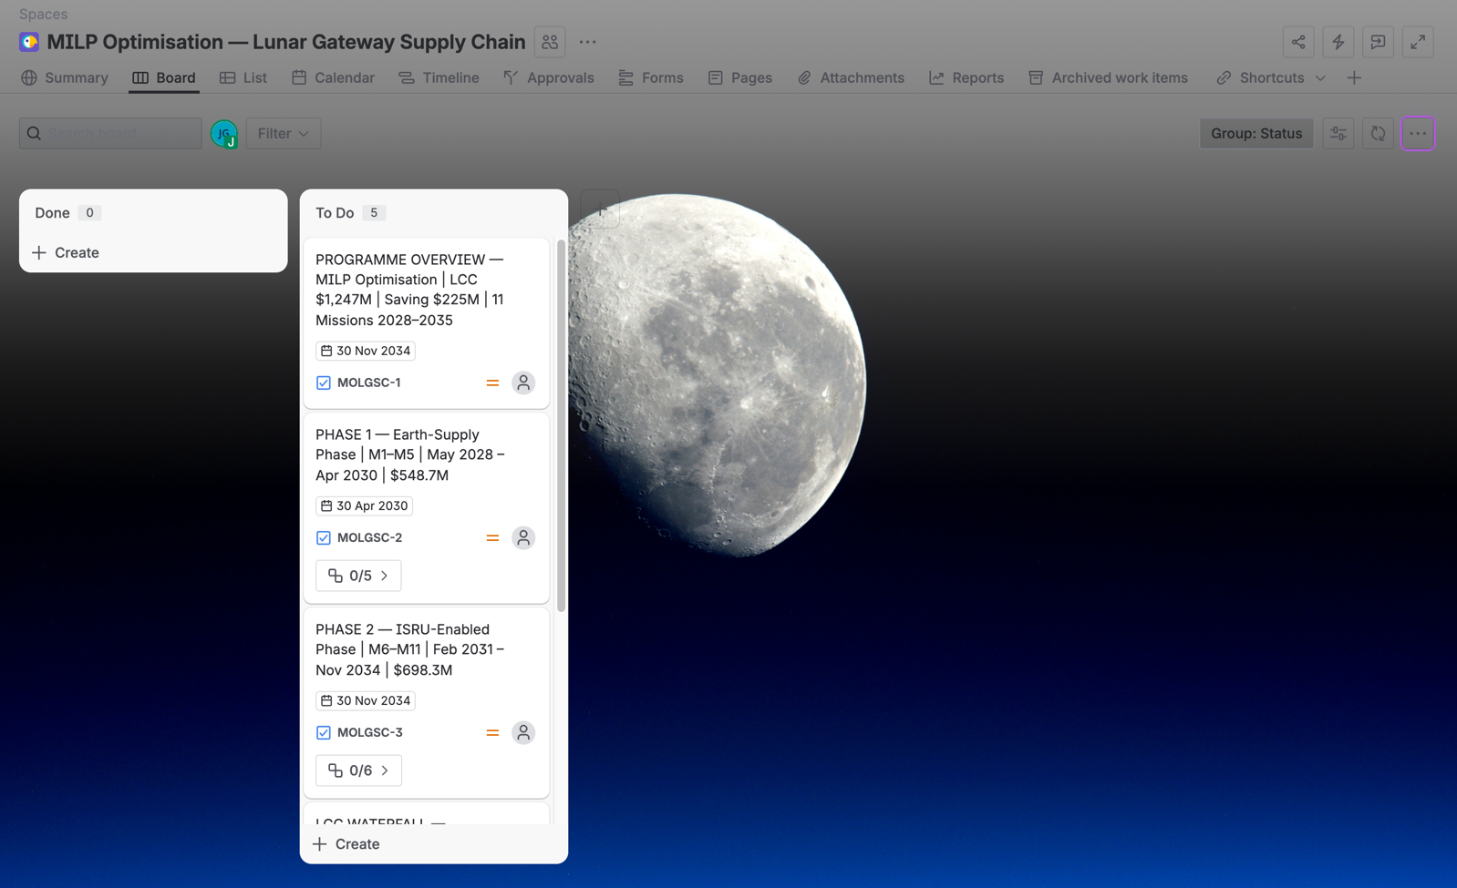

E.4 Excel Project Plan -Lunar_Gateway_Project_Plan_Professional.xlsx
The Excel project plan provides a full Gantt chart and task breakdown for the 13-week EG7302 project period (26 January – 27 April 2026). It complements the Jira tracking system with a visual timeline, resource allocations, milestone tracking, and the complete Work Breakdown Structure.
ATTACH FILE - Project Plan Excel
• Outputs/Lunar_Gateway_Project_Plan_Professional.xlsx (primary - full Gantt, WBS, milestones, resource plan)
• Outputs/Lunar_Gateway_Project_Plan_Compressed.xlsx (compressed version for email/Blackboard upload)
• Outputs/lunar_gateway_project_plan.xlsx (original draft plan)

 | Content | Key Columns
PROJECT GANTT | Week-by-week Gantt chart for all 13 weeks; 40 tasks colour-coded by phase; milestones marked as diamonds | Task ID, Task Name, Phase, W1–W13 (26 Jan to 27 Apr), Duration, Status
WBS BREAKDOWN | Full Work Breakdown Structure - 4 Level 1 phases, 10 Level 2 work packages, 40 Level 3 tasks | WBS Code (e.g., 1.2.3), Task Name, Owner, Effort (hrs), Start Date, End Date, Dependencies
MILESTONES | 9 key project milestones with target dates and actual completion dates | MS#, Milestone, Target Date, Actual Date, Status (On-Track/Delayed/Complete)
RESOURCE PLAN | Effort allocation by week for each analytical module | Module, W1–W13 hours, Total Hours, % of 400hr project budget
COST MODEL REF | Links to Gateway_Cost_Model_Interactive.xlsx Monte Carlo inputs | CER equations, input ranges, Crystal Ball/@RISK cell assignments
Table E 6 Excel project plan - sheet contents and key columns

E.5 MILP Optimal Resupply Gantt Charts (2028–2035)
Three separate MILP Gantt visualisations were produced, each serving a different purpose and audience. All three represent the same underlying MILP optimal schedule (11 missions, 2028–2034, LCC=$1,247M) but with different levels of detail and interactivity.

E.5.1 MATLAB/PNG Gantt (Dissertation Figure)
The primary dissertation figure (F4_6_MILP_Gantt.png) was generated by the MATLAB script milp_optimization.m using the NASA/Berkeley Earth colour palette. It comprises two panels: (1) mission bars coloured by vehicle (Falcon Heavy navy #222288; Vulcan Centaur red #CC0000) across 2028–2035; and (2) gateway inventory trace showing the sawtooth resupply pattern with safety stock floor at 193 kg and ISRU gold-fill offset from 2030.
FIGURE 4.6 FILES
• MAT Lab/figures/F4_6_MILP_Gantt.png (300 DPI, dissertation figure - insert in report)
• MAT Lab/milp_optimization.m (MATLAB source - run to regenerate)
• Python Scripts/milp_optimization.py (Python source - alternative generation)

E.5.2 Interactive HTML Gantt
MILP_Gantt_ProjectLibre_Style.html provides a interactive Gantt with left-side grid columns (WBS number, Task Name, Duration, Start, End) and colour-coded bars on the right. Features: hover tooltips on each mission bar showing full details; drag-to-pan across 2028–2035; print-to-PDF button. Open in Chrome, Firefox, or Edge.

